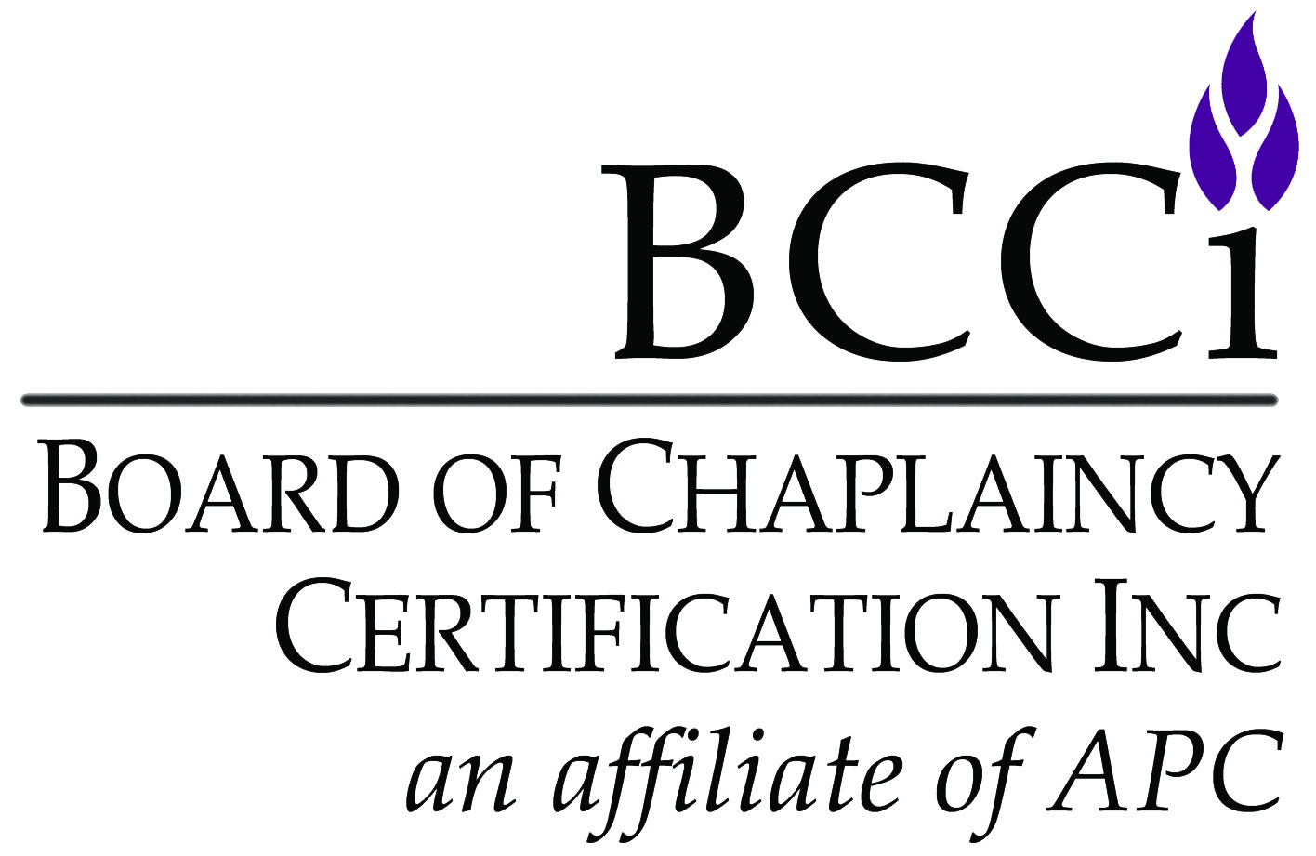
Board of Chaplaincy Certification Inc.
an affiliate of Association of Professional Chaplains
2800 West Higgins Road, Suite 295 • Hoffman Estates, IL 60169
bcci@professionalchaplains.org • www.professionalchaplains.org/BCCI
Phone: 847.240.1014 • Fax: 847.240.1015

CHECKLIST FOR REGULAR APPLICANTS
(board certified & provisional board certified chaplain and associate certified & provisional associate certified chaplain)

IMPORTANT NOTES:
- Candidates must submit a complete file. Application is complete ONLY after all materials are received, all equivalencies
(if any) approved and all fees paid. All application materials listed below must be submitted and are not optional.
- Incomplete applications will be mailed back, and BCCI will retain a $50 administration fee for reviewing and returning incomplete materials. The candidate will have to reapply in the future.
- Submit the current application. Standards are subject to change, and you will be held to the standards in place for the year in which you apply. If your application is outdated, it will be returned to you for resubmission.
- Provide documentation of current endorsement or of good standing in accordance with your own spiritual/faith group (received or reaffirmed within last 12 months). The letter must be mailed, emailed, or faxed directly to the BCCI office from your spiritual/faith group. Contact your spiritual/faith group as soon as possible to obtain your letter, as this process can take many months to complete. Spiritual/Faith groups must be recognized by the Department of Defense (Armed Forces Chaplains Board) or previously reviewed and approved by BCCI. If not, contact BCCI regarding a review of the spiritual/faith group.
- Please submit one-sided documents ONLY.
- Application forms must be typed.
- Please no plastic sleeves, binders, staples, or paperclips.
- Complete application and supporting documents are valid only for one year (12 months) from the date they were received by BCCI.

Items that Must be Submitted by CANDIDATE:
- Application form
- Application fee (check made payable to Board of Chaplaincy Certification Inc. or provide credit card information)
- Official graduate degree(s) transcripts or equivalency materials
- Letter from employer to verify 2,000 hours of work experience as a chaplain or equivalency materials
(This item does not apply to candidates seeking provisional certification.)
- Recommendation letter from board certified chaplain of APC/BCCI, ACPE, CASC, NACC, NAJC or NAVAC
- Recommendation letter from a certified/licensed peer professional like a nurse, a doctor, or a social worker
- Evidence of CPE units, or equivalency materials
Board certified chaplain and provisional board certified chaplain candidates must have completed four (4) units confirmed by an ACPE Verification Transcript, or certificate of completion from each unit, or the overall certification from the residency; associate certified chaplain and provisional associate certified chaplain candidates must have completed two (2) units confirmed by an ACPE Verification Transcript, or certificate of completion from each unit. To request a transcript of your clinical pastoral education units completed with ACPE, please click here: https://www.acpe.edu/ACPE/Resources/TranscriptsOnDemand.aspx
- Two (2) clinical chaplain contact narratives with cover pages
- Autobiography
- Four (4) competency essays
- Accountability for Ethical Conduct form
Item that Must be Sent Directly to BCCI Office by SPIRITUAL/FAITH GROUP:
- Documentation of current endorsement or of good standing in accordance with your own spiritual/faith group.
APPLICATION FORM FOR REGULAR APPLICANTS
Complete ALL sections of application form.

NOTE: To qualify for the APC member rate, you must be current with APC membership dues. BCCI certification does NOT include membership in the APC. Interested in becoming a member? Contact the APC office.

I am applying for (check one):

board certified chaplain ($395/APC member, $545/nonmember)
provisional board certified chaplain ($395/APC member, $545/nonmember)
associate certified chaplain ($395/APC member, $545/nonmember)
provisional associate certified chaplain ($395/APC member, $545/nonmember)
Personal Information
Salutation: Mr. Ms. Mrs. Chaplain Rev. Rabbi Father Sister Brother Imam Dr. Rev. Dr.
CH (MAJ) CH (COL) Deacon Deaconess Pastor Cantor Venerable
Spiritual/Faith Group:
Applicant’s Full Name:
Home Address: City / State / Zip:
Home Phone Number: Cell Phone Number:
Home E-mail: Preferred Pronouns:

Demographic Information (only used to report aggregate information about certified chaplains) | Birth date:  Month/Year | Gender: | Ethnicity:
 |  | Male Female  Transgender Male  Transgender Female  Gender variant/non-conforming  Non-binary  Not Listed | Asian  Black/ African American  White  American Indian or Alaska Native  Hispanic/Latinx  Native Hawaiian or Pacific Islander  Other Please Specify

Please select the ONE that best describes your current work setting:
Business/Workplace | Hospital | Hospice | Palliative Care | School/University | VA Medical Facility
Corrections | Long-term Care | Military | Pediatrics | Sports | Other
Faith Community | Mental Health | Oncology | Rehabilitation Facility | Uniformed Services (police/fire/EMT)
Employer:
Position:
Work Address:
City / State / Zip Code:
Work Phone Number: Work E-mail:
I prefer to be contacted at: Home Work (please select only one)

Education Documentation

Please check one:

I have been awarded an education equivalency. Leave graduate school information below blank for an equivalency.

I have completed a transcript review with BCCI. Include a copy of the determination letter and complete sections 2 and/or 3 below.

I am providing a summary of my academic history. Complete sections 1-3 below.
Section 1
List the qualifying graduate degree and the awarding institution. List the total number of hours earned in the Hours Awarded box. A qualifying degree must be awarded by a CHEA accredited institution in the academic disciplines of Theology, Philosophy, or Psychology. The qualifying degree must contain a minimum of 30 graduate semester hours. Attach the transcript.
Section 2
Applicants seeking the Board Certified Chaplain (BCC) designation must demonstrate a minimum of 72 graduate semester hours or equivalent credits. Applicants seeking the Associate Certified Chaplain (ACC) designation must demonstrate a minimum of 48 graduate semester hours. List the institutions and total number of graduate hours awarded for all completed courses except for the Qualifying Degree in Section 1. For BCC applicants, CPE units 5-7 may be included. For ACC applicants, CPE units 3-5 may be included. Each unit of CPE is awarded 5 semester hours. All units must be completed at Association of Clinical Pastoral Education (ACPE) accredited sites.

Section 3
Provide a list of courses demonstrating study in Professional Competence courses. All applicants must demonstrate a total 24 graduate semester hours of CHEA accredited coursework with a minimum of one course earned in 3 of 4 subject areas and documented on an academic transcript: World Religions, Spiritual Practices-Practical Ministry, History of a Religious-Philosophical Tradition, Sacred-Foundational Texts. Professional Competence courses may be earned outside of the Qualifying Degree. See Professional Course Competencies for examples at this link: https://bcci.professionalchaplains.org/content.asp?admin=Y&pl=16&sl=16&contentid=30

Section 1, Qualifying Graduate Degree |  |  |  |  | CHEA Accredited |  | Earned Hours
Degree |  |  |  |  | Yes  No
Institution
Section 2, Additional Graduate Courses and Additional CPE |  |  |  |  | CHEA or ACPE Accredited |  | Earned Hours
Institution
Institution
Institution
Total Graduate Academic Hours and Credits in Sections 1 and 2

Section 3, Professional Competence Courses
- Identify the subject area for each course by subject number
- A minimum of three subject areas must be represented:
1. History of Religion or Philosophy
2. Sacred or Foundational Texts
3. Practical Ministry or Spiritual Care,
4. World Religions
Subject # | Course Name | Institution | CHEA Accredited |  | Earned Hours
Total Graduate Semester Hours Earned in Section 3 (Minimum 24 hours)

Work Experience

I am submitting letter(s) from my administrator(s) verifying 2,000 hours of work experience as a chaplain
(board certified chaplain & associate certified chaplain)
I am requesting an equivalency for 2,000 hours of work experience.
Attach ACPE transcript with units 5-8 for 250 hours per unit and/or attach a completed work experience equivalency
worksheet for hours earned via research.
I am applying for provisional board certified chaplain or provisional associate certified chaplain
Spiritual/Faith Group Endorsement Letter

1. Letter of Endorsement/Support from Spiritual/Faith Group
Provide documentation of current endorsement or of good standing in accordance with your own spiritual/faith group (received or reaffirmed within last 12 months) by a recognized religious spiritual/faith group for work as a chaplain. The letter must be mailed, emailed, or faxed directly to the BCCI office from your spiritual/faith group.
Spiritual/Faith Group:
Endorser’s Name (individual signing current letter):
Endorsement Date (date of current letter):

Recommendation Letters (3)
You are responsible for obtaining the three (3) recommendation letters. You must have three (3) separate recommendation letters from three (3) different individuals. All letters must recommend you for certification by BCCI. All letters must be dated with a real signature (not a computer script font).

1. Administrator’s Recommendation Letter
You must submit a letter of recommendation from the administrator who evaluates your pastoral, administrative, and/or clinical competence. The administrator must identify him/herself as your current supervisor.
Name:

2. Board Certified Chaplain Recommendation Letter
You must submit a letter of recommendation from a chaplain who is certified by one of the organizations listed below.
Select the group with which the chaplain is certified: APC/BCCI ACPE CASC NACC NAJC NAVAC
Name:
3. Certified/Licensed Peer Professional Recommendation Letter
Candidate must submit a letter from certified/licensed peer professional, other than a non-certified chaplain, (e.g., nurse, doctor, social worker) with whom the candidate has a working relationship.
Name:

Clinical Pastoral Education (CPE)
List in chronological order (earliest to latest) the first four units of CPE and submit documentation in the form of an ACPE Verification Transcript, or certificates received at the completion of each unit, or the certification from the overall residency.
Note: Only one unit of properly accredited CPE used to meet the graduate school semester credits requirement under “Education Documentation” can be used again in this section.
Completed four (4) units of CPE (board certified chaplain, provisional board certified chaplain)
Completed two (2) units of CPE (associate certified chaplain, provisional associate certified chaplain)
Unit | CPE Center | ACPE Accredited |  | Dates
Unit | CPE Center | YES | NO | Dates
1 |  |  |  | / / - / /
2 |  |  |  | / / - / /
3 |  |  |  | / / - / /
4 |  |  |  | / / - / /
I am requesting CPE Equivalency because unit(s) taken was not from an accredited CPE center. Clinical Pastoral Education Equivalency Worksheet attached.

Accountability for Ethical Conduct
Complete and return the Accountability for Ethical Conduct form.
Consent
I certify that the information in my application materials is accurate and true. I hereby authorize the BCCI office, the Commission on Certification, and certification committee to review and verify my application materials. I understand that providing false, incomplete or misleading information may result in denial of my application. I understand that my application materials will not be shared by BCCI outside of its processes.

 SIGNATURE: DATE:

Certificate: I would like my name to appear as follows on my certificate, if recommended for certification (you may include titles and credentials, if you would like):


To pay with a credit card, please use the section below.

Board Certified Chaplain ($395/APC member, $545/nonmember)

Provisional Board Certified Chaplain ($395/APC member, $545/nonmember)

Associate Certified Chaplain ($395/APC member, $545/nonmember)

Provisional Associate Certified Chaplain ($395/APC member, $545/nonmember)
VISA MASTERCARD DISCOVER AMEX
Amount: $
Card Number:
Security Code:
Exp. Date:
Billing Name:
Billing Address:

