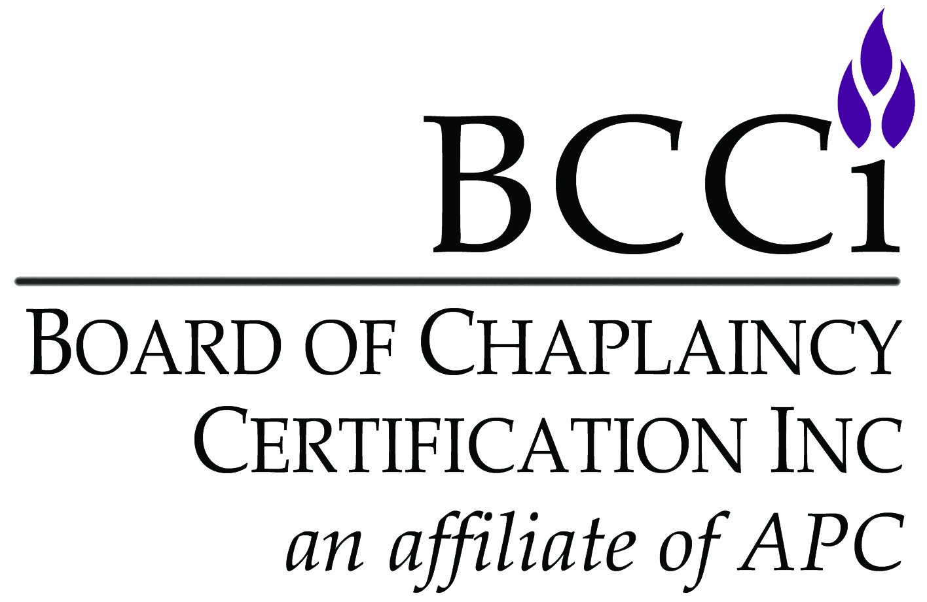
Board of Chaplaincy Certification Inc.
an affiliate of Association of Professional Chaplains
2800 West Higgins Road, Suite 295 • Hoffman Estates, IL 60169
bcci@professionalchaplains.org • www.professionalchaplains.org/BCCI
Phone: 847.240.1014 • Fax: 847.240.1015

APPLICATION FORM FOR MILITARY SPECIALTY CERTIFICATION
NOTE: To qualify for the APC member rate, you must be current with APC membership dues

I am applying for (check one):

$467/APC member $572/nonmember)
- Please submit one-sided documents ONLY.
- Please no plastic sleeves, binders, staples or paperclips.

Personal Information
Salutation: Mr. Ms. Mrs. Chaplain Rev. Rabbi Father Sister Brother Imam Dr. Rev. Dr.
CH (MAJ) CH (COL) Deaconess Pastor
Religious Endorsing Body:
Applicant’s Full Name:
Home Address:
City / State / Zip Code:
Home Phone Number:
Home E-mail:

Demographic Information (optional) | Date of Birth: | Sex: | Ethnic Group:
Demographic Information (optional) | / / | Male | African American | Caucasian | Hispanic
Demographic Information (optional) |  | Female | American Indian | Asian | Other

Employer:
Position:
Work Address:
City / State / Zip Code:
Work Phone Number:
Work Fax Number:
Work E-mail:
I prefer to be contacted at: Home Work

Recommendation Letters (3)
You are responsible for obtaining the three (3) recommendation letters. You must have three (3) separate recommendation letters from three (3) different individuals. All letters must recommend you for specialty certification by BCCI.

1. Military Chaplain Supervisor’s Recommendation Letter
You must submit a letter of recommendation from a military chaplain supervisor (that includes verification that the military experience requirements have been met)
Name:

2. Non-chaplain Military Officer Recommendation Letter

You must submit a letter of recommendation from one (non- chaplain) 04 and above military officer who has served or is serving with you
Name:
3. Endorser Recommendation Letter
Name:

Specialty Continuing Education Hours
List specialty continuing education hours received over the past one to three years (must be 50 hours). May also attach an APC Continuing Education form which has been previously submitted.
Date | Event Type e.g. workshop, lecture, webinar | Title / Topic | Sponsoring Organization |  | HOURS
Total

Consent
I certify that the information in my application materials is accurate and true. I hereby authorize the BCCI office, the Commission on Certification and Certification Committee to review and verify my application materials. I understand that providing false, incomplete or misleading information may result in denial of my application. I understand that my application materials will not be shared by BCCI outside of its processes.


^{Signature} ^{Date}

