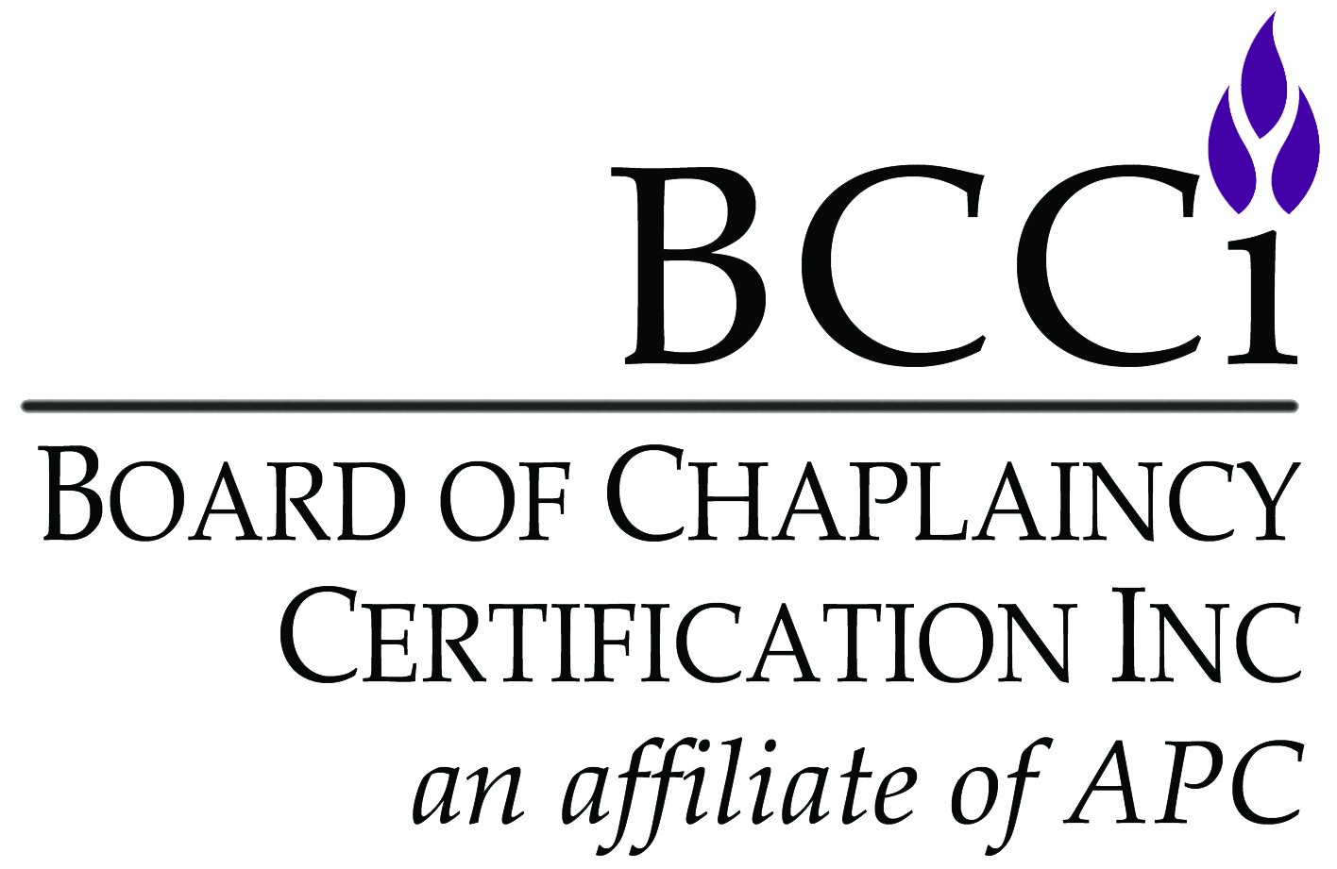
Board of Chaplaincy Certification Inc.
An affiliate of Association of Professional Chaplains
2800 West Higgins Road, Suite 295 • Hoffman Estates, IL 60169
bcci@apchaplains.org • www.apchaplains.org/bcci-site/
Phone: 847.240.1014 • Fax: 847.240.1015

CHECKLIST FOR SUBSEQUENT APPEARANCE - For Applications Originally Submitted on Paper (online applicants will need to submit through the online portal)

IMPORTANT NOTES:
- Candidates must submit a complete file. Application is complete ONLY after all materials are received and all fees paid. All application materials listed below must be submitted and are not optional.
- Incomplete applications will be mailed back, and BCCI will retain a $50 administration fee for reviewing and returning incomplete materials. The candidate will have to reapply in the future.
- Please submit one-sided documents ONLY.
- Please no plastic sleeves, binders, staples or paperclips.
- Application form must be typed
- Complete application and supporting documents are valid only for one year (12 months) from the date they were received by BCCI.

Items that Must be Submitted by CANDIDATE:
- Application form with current information
- Application fee (check made payable to Board of Chaplaincy Certification Inc. or credit card information)
- Essay addressing any competencies marked as unmet by previous BCCI committee. Essays (2 pages per competency) should be double-spaced, using a 12-point font and one-inch margins. Please note: your previous application materials are not sent to the new committee. The only materials sent are what you submit at this time.
- Updated autobiography (not to exceed 5 double-spaced pages, 12-point font and one-inch margins)
- Chaplain Clinical Contact with cover sheet demonstrating one or more of missed competencies (at least 5 single-spaced pages and not more than 12 pages, using a 12-point font and one-inch margins). Must be a new Contact written within 12 months of subsequent appearance application.
- Complete and signed Accountability for Ethical Conduct Form.

The candidate must complete the requirements and application process for reappearance within two years of the initial ratification date. After two years, the candidate must completely reapply.

APPLICATION FORM FOR SUBSEQUENT APPEARANCE - For Applications Originally Submitted on Paper (online applicants will need to submit through the online portal)
Complete ALL sections of application form.
I am applying for (check one):
Board Certified Chaplain / Provisional Board Certified Chaplain
Associate Certified Chaplain / Provisional Associate Certified Chaplain

Video Conferencing Interview – Must Have Computer or Tablet Webcam ($160 member / $190 non-member)

Personal Information
Salutation: Mr. Ms. Mrs. Chaplain Rev. Rabbi Father Sister Brother Imam Dr. Rev. Dr.
CH (MAJ) CH (COL) Deacon Deaconess Pastor Cantor Venerable
Spiritual/Faith Group:
Applicant’s Full Name:
Home Address:
City / State / Zip Code:
Home Phone Number: Cell Phone Number
Home E-mail:

Please select the ONE that best describes your current work setting:
Business/Workplace | Hospital | Hospice | Palliative Care | School/University | VA Medical Facility
Corrections | Long-term Care | Military | Pediatrics | Sports | Other
Faith Community | Mental Health | Oncology | Rehabilitation Facility | Uniformed Services (police/fire/EMT)
Employer:
Position:
Work Address:
City / State / Zip Code:
Work Phone Number:
Work Fax Number:
Work E-mail:
I prefer to be contacted at: Home Work (please select only one)

Spiritual/Faith Group Endorsement Letter
You are responsible for obtaining a current endorsement letter ONLY if you changed spiritual/faith group after your original application was submitted.

1. Letter of Endorsement/Support from Spiritual/Faith Group
Provide documentation of current endorsement or acceptable language in accordance with your own spiritual/faith tradition (received or reaffirmed within last 12 months) by a recognized religious spiritual/faith group for work as a chaplain. The letter must be mailed, emailed, or faxed directly to the BCCI office from your spiritual/faith group.
Spiritual/Faith Group:
Endorser’s Name:
Endorsement Date:

Recommendation Letter
You are responsible for obtaining a current recommendation letter ONLY if you changed employment after your original application was submitted.

1. Administrator’s Recommendation Letter
You must submit a letter of recommendation from the administrator who evaluates your pastoral, administrative, and/or clinical competence. The administrator must identify him/herself as your current supervisor. If your administrator was one of your CPE supervisors listed on this application, you should request an Administrator Letter from another person you report to who has responsibility for and knowledge of your work as a chaplain (e.g., a nurse manager or HR manager.)
Name:

Accountability for Ethical Conduct
Complete and return the Accountability for Ethical Conduct form.

Consent
I certify that the information in my application materials is accurate and true. I hereby authorize the BCCI office, the Commission on Certification, and certification committee to review and verify my application materials. I understand that providing false, incomplete or misleading information may result in denial of my application. I understand that my application materials will not be shared by BCCI outside of its processes.

SIGNATURE: DATE:

Certificate: I would like my name to appear as follows on my certificate, if recommended for certification (you may include titles and credentials, if you would like):


To pay with a credit card, please use the section below.

board certified chaplain ($160 member / $190 non-member)

provisional board certified chaplain ($160 member / $190 non-member)

associate certified chaplain ($160 member / $190 non-member)

provisional associate certified chaplain ($160 member / $190 non-member)
VISA MASTERCARD DISCOVER AMEX
Amount: $
Card Number:
Security Code:
Exp. Date:
Billing Name:
Billing Address:

