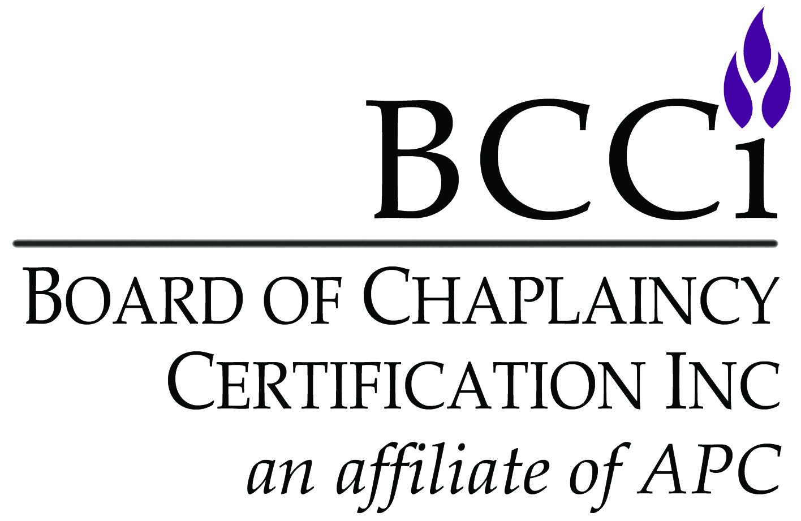
Board of Chaplaincy Certification Inc.
an affiliate of Association of Professional Chaplains
2800 West Higgins Road, Suite 295 • Hoffman Estates, IL 60169
bcci@apchaplains.org • www.apchaplains.org/bcci-site
Phone: 847.240.1014 • Fax: 847.240.1015

Name:
Address:
E-mail:
Phone number:
Equivalency Fee: | $58.00 Member $115.50 Non-Member  (Equivalency fees are non-refundable)
Please login to the APC website to process your equivalency request and to receive further instructions.
The link to order is https://www2.apchaplains.org/forms/store/ProductFormPublic/bcci--cpe-equivalency-request

Clinical Pastoral Education Equivalency Worksheet

All decisions made by the Commission on Certification are final.
Up to (4) four units of CPE, completed before January 1, 2024 may be requested in an equivalency. Equivalency requests must be accompanied by this application and appropriate fees.

Document all of the elements of the clinical program as follows. All of the areas must be addressed and are not optional. Please type each item listed below and label with the appropriate number
(e.g., 1., 2., 5. a., 5. b., etc.) as you respond.
Candidates must request a detailed evaluation from their supervisors/instructors, addressing the goals of the learning experience.
For your reference, competencies identified in the APC standards, are listed on page 2.
1. | State clearly the reason you are seeking an equivalency for clinical training.
2. | How has the program enabled you to achieve the competencies identified in the APC standards?
3. | How does the educational experience relate to your ministry and development as a pastoral care professional?
4. | How has the equivalency provided opportunity for the integration of your personal and professional development, clinical and academic learning, theology, and social sciences?
5. | Document the following for the unit:
 | a. | Completion of a minimum of 400 hours (equivalent to one unit of CPE), including supervision, group, classroom, and clinical ministry.
 | b. | Individual supervision of ministry by a person who is appropriately credentialed to conduct such an alternative program. Provide supervisor’s credentials. An appropriately credentialed supervisor is an individual who has had significant post-graduate training in adult education, group dynamics, individual supervision, theology, and clinically based pastoral care, equivalent to that of a CPE, CASC, or NACC certified supervisor. This person must adhere to a Common Code of Ethics as established by his/her certifying organization.
 | c. | Didactic sessions on professional functioning and theological reflection.
 | d. | Interpersonal sharing in a peer group
 | e. | Attention to personal, pastoral, and professional identity issues

COMMON COMPETENCIES FOR PROFESSIONAL CHAPLAINS

All competencies described below apply to board certified chaplains, provisional board-certified chaplains, associate certified chaplains and provisional associate certified chaplains.
Essay I: Integration of Theory and Practice Competencies
ITP1: | Articulate an approach to spiritual care, rooted in one’s faith/spiritual tradition that is integrated with a theory of professional practice.
ITP2: | Incorporate a working knowledge of psychological and sociological disciplines and religious beliefs and practices in the provision of spiritual care.
ITP3: | Incorporate the spiritual and emotional dimensions of human development into one’s practice of care.
ITP4: | Incorporate a working knowledge of different ethical theories appropriate to one’s professional context.
ITP5: | Articulate a conceptual understanding of group dynamics and organizational behavior.
ITP6 | Articulate how primary research and research literature inform the profession of chaplaincy and one’s spiritual care practice.
Essay II: Professional Identity and Conduct Competencies
PIC1: | Be self-reflective, including identifying one’s professional strengths and limitations in the provision of care.
PIC2: | Articulate ways in which one’s feelings, attitudes, values, and assumptions affect professional practice.
PIC3: | Attend to one’s own physical, emotional, and spiritual well-being.
PIC4: | Function in a manner that respects the physical, emotional, cultural, and spiritual boundaries of others.
PIC5: | Use one’s professional authority as a spiritual care provider appropriately.
PIC6: | Advocate for the persons in one’s care.
PIC7: | Function within the APC Code of Professional Ethics.
PIC8: | Communicate effectively orally and in writing.
PIC9: | Present oneself in a manner that reflects professional behavior, including appropriate attire, and grooming.
Essay III: Professional Practice Skills Competencies
PPS1: | Establish, deepen, and conclude Professional spiritual care relationships with sensitivity, openness, and respect.
PPS2: | Provide effective spiritual support that contributes to well-being of the care recipients, their families, and staff.
PPS3: | Provide spiritual care that respects diversity and differences including, but not limited to culture, gender, sexual orientation, and spiritual/religious practices.
PPS4: | Triage and manage crises in the practice of spiritual care.
PPS5: | Provide spiritual care to persons experiencing loss and grief.
PPS6: | Provide religious/spiritual resources appropriate to the care recipients, families, and staff.
PPS7: | Develop, coordinate, and facilitate public worship/spiritual practices appropriate to diverse settings and needs.
PPS8: | Facilitate theological/spiritual reflection for those in one’s care practice.
PPS9 | Facilitate group processes, such as family meetings, post trauma, staff debriefing, and support groups.
PPS10 | Formulate and utilize spiritual assessments, interventions, outcomes, and care plans in order to contribute effectively to the well-being of the person receiving care.
PPS11 | Document one’s spiritual care effectively in the appropriate records.
Essay IV: Organizational Leadership Competencies
OL1: | Promote the integration of spiritual care into the life and service of the institution in which one functions.
OL2: | Establish and maintain professional and interdisciplinary relationships.
OL3: | Understand and function within the institutional culture and systems, including utilizing business principles and practices appropriate to one’s role in the organization.
OL4: | Promote, facilitate, and support ethical decision-making in one’s workplace.
OL5: | Foster a collaborative relationship with community clergy and faith group leaders.

