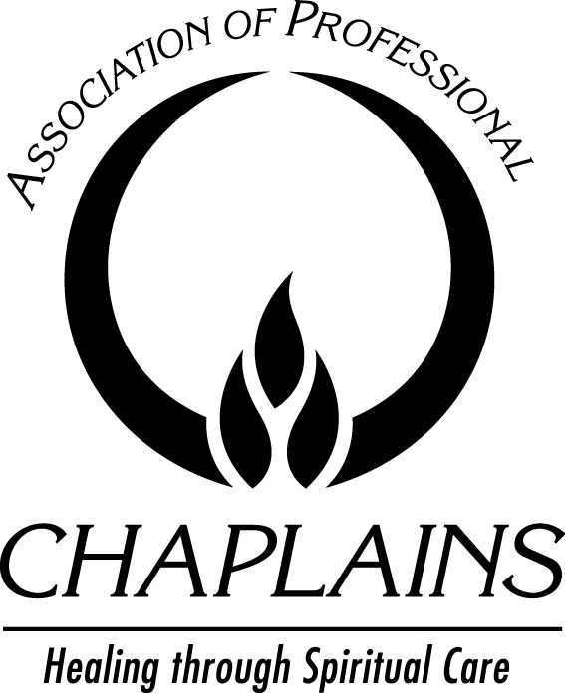
APC Forum
News and Ideas in Chaplaincy Care

COPYRIGHT RELEASE

By returning this form, the author grants and assigns exclusively to Association of Professional Chaplains, publisher of APC Forum, for its use, any and all rights of whatsoever kind or nature now or hereafter protected by the Copyright Laws (common or statutory) of the United States and all foreign countries, in all languages, in and to the above named article, including all subsidiary rights and the right to reprint by electronic, print or other means.

The Association of Professional Chaplains, publisher of APC Forum, in turn, grants to the author the right of republication in any book of which s/he is the author, editor, or contributor. We ask that notification is given to the Association of Professional Chaplains national office and a proper credit line included:

This (article/essay/poem/art/photo) originally appeared in APC Forum, published by Association of Professional Chaplains, volume: number (year). Reprinted with permission of APC.

Please complete the following and return this form via e-mail to info@professionalchaplains.org or fax to 847.240.1015. Be sure to keep a copy for your file.

Today’s Date
Publication Date
Title(s) of work
Name (as you wish it to be printed)
Position title
Institution (include city/state)
Highest academic degree(s)
Category of APC membership
please specify BCC, provisional certified chaplain,
associate chaplain, affiliate, student affiliate
Other certifications (optional)
Ecclesiastical title (optional)
Ordained | Yes No
Faith group endorsement (optional)
E-mail address to be printed in
APC e-NEws

The author guarantees that the material furnished to APC Forum has not been published elsewhere.
This material has been previously published. (Include copy for appropriate credit lines.) I have attached:
Written documentation that the copyright is held by the author OR
Written permission from the publisher/copyright holder to republish the material in APC Forum.

I understand and agree to the terms outlined above:
Signature | Date

Association of Professional Chaplains • 2800 W. Higgins Rd., Suite 295 • Hoffman Estates, IL 60169 • 847.240.1014

