Board of Chaplaincy Certification Inc.
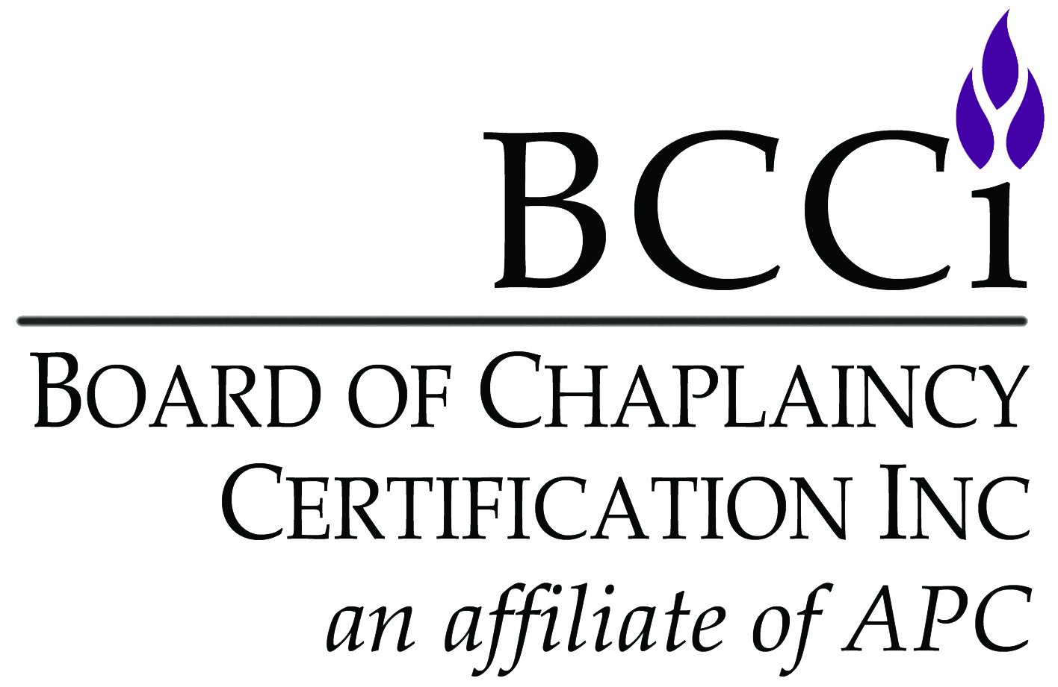
an affiliate of Association of Professional Chaplains
2800 West Higgins Road • Suite 295 • Hoffman Estates, IL 60169
bcci@professionalchaplains.org • www.professionalchaplains.org/BCCI
Phone: 847.240.1014 • Fax: 847.240.1015

ACCOUNTABILITY FOR ETHICAL CONDUCT

Please read carefully and complete Sections I or II.

Section I: I certify that (a) no complaint against me for unethical conduct has been filed, is pending, or has been settled in a civil, criminal, ecclesiastical, employment or another professional organization’s forum; and (b) I have never resigned, been terminated nor negotiated a settlement from a position for reasons related to unethical conduct.

SIGNATURE: DATE:

Section II: If the above cannot be certified, provide an account of the complaint including the forum, charges, and final outcome. Provide contact information for people involved in the process, whom you authorize to give full information to APC/BCCI representatives. Each situation will be evaluated on its own merits by the accountability review panel. Prior complaints are not an automatic bar to membership. Information obtained will not be sent to the certification committee. BCCI has the right to accept or deny an applicant according to the judgment of the accountability review panel, regardless of previous complaints, other forum’s findings or the applicant’s subsequent remedial actions. If denied, the applicant may resubmit an application at a later time. Decisions are final and binding. (Attach pages if necessary.)

Please read carefully and sign Section III.

Section III: I understand that as a condition of certification by BCCI and membership in the Association of Professional Chaplains, I will provide to the association timely notice of any complaint of unethical conduct filed against me (APC Code of Ethics, Standard 130.34). I agree to provide to the APC Commission on Professional Ethics in a timely fashion the information it requests regarding the investigation, adjudication, dismissal or settlement of such complaint. Failure to report or provide accurate, full and truthful information may be grounds for discipline including removal of membership in the Association of Professional Chaplains and removal of BCCI certification.

SIGNATURE: DATE:

PRINTED NAME:

